
ATTAQUANT ENTERPRISES PVT. LTD.

Questionnaire for Reboiler
Name of Company
Address
Name of Concerned Person
PERFORMANCE OF ONE UNIT
Fluid allocation |  | Shell side |  | Tube side
Fluid name
Fluid quantity (total)kg/h
Vapor (in/out) -kg/h
Liquid- kg/h
Non-condensable -kg/s
Temperature (in/out)- ⁰C
Dew/Bubble point- ⁰C
Density- kg/m³
Viscosity -cp
Molecular wt. Vap
Molecular wt. NC
Specific Heat-kcal/(kg*C)
Thermal conductivity- kcal(h*m*C)
Latent heat-kcal/kg
Pressure-kgf/cm²
Pressure drop allow/calc.-kgf/cm²
Velocity-m/s
Fouling resistance-m²*h*C/kcal
Radiography required or not

CONSTRUCTION OF ONE SHELL |  |  | Sketch
Design/ test pressure -kgf/cm² | Shell Side | Tube Side
Design temperature-⁰C
Number of passes per shell
Corrosion allowance- mm
Remarks

ATTAQUANT ENTERPRISES IS AN ISO 9001:2015 CERTIFIED ORGANIZATION
Yours Faithfully,
For ATTAQUANT ENTERPRISES PVT LTD
VIJAY PINATE
Mobile: +918788482769

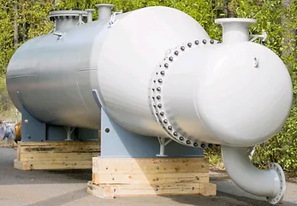
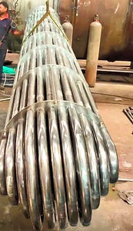

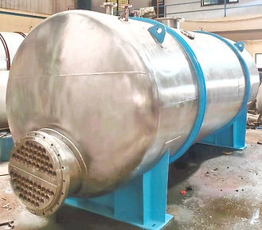
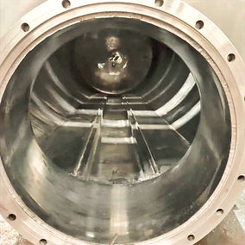
 Corporate Office:
601 (M 90), City Avenue,
Near Sayaji Hotel, Bhumkar, Chowk,
Wakad, Pune (Maharashtra), 411057,
India.

 +91–8788482769/+91-9423589966
 contact@attaquant.in, info@attaquant.in
Hyderabad Office:
Sales & Service – Office 1C,
Nandanavanam Complex, Sanjeeva Reddy Nagar, Near Metro Station, Hyderabad, 500038, India.

 +91–8788482769
 contact@attaquant.in
Manufacturing Unit:
Alandi Bypass Road, Gat No.138,
Near Growel Company,
At Post, Dhanore, Tal. Khed, Dist. Pune,
Maharashtra- 412105, India.

 +91–9145205069
 services@attaquant.in

